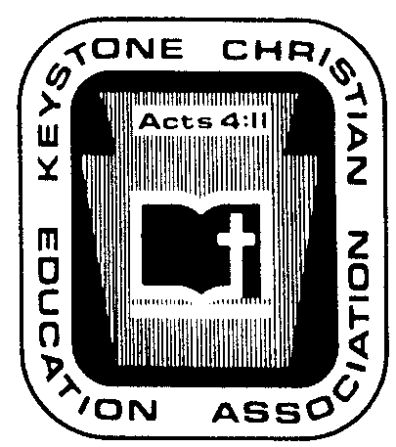
Keystone Christian Education Association

6101 Bell Road

Harrisburg, PA 17111
Phone (717) 564-1164

Fax (717) 564-1163

E-mail TClater@KCEA.com

Web www.KCEA.com

NOVEMBER ’22 NEWS NOTES

P.R. IDEA OF THE MONTH. FOUR “WHAMMIES” AGAINST ART, MUSIC, AND PHYSICAL EDUCATION. (1) The STEM emphasis caused some to shrink time-on-task for the humanities and arts; and thinkers quickly realized that STEM was unbalanced. (2) …
…
…
…
We all know that there are real benefits in prioritizing that education is the focal point of all three. We all know that we should find ways to improve our priorities, for the betterment of our institutional reputations (and attractiveness to prospective families), our schools, and our students.

It is important for school leaders to get it done.

SPECIAL REPORT, PROTECTIONS AND GUIDANCE FOR LEADERS AND INSTITUTIONS IN THE AREA OF SEX-RELATED CHILD ABUSE AND CRIME. In this space it is not our intent to duplicate the Report. A copy is attached for your current reading and future reference. Yes, we have utilized legal counsel in these matters.

As noted, the topics covered in this Report have generated questions by leaders, and KCEA staff has regularly answered these. By experience we all know that when a few ask, others are also in need. If more helps are needed, we can schedule a consultation and/or arrange an administrative seminar.
…
…
…
…

2022 KCEA ALL-STATE CHOIR. Right on the assigned dates before Thanksgiving, 110 high school students in affiliating schools from across the state got together for some serious music education and choral music training.
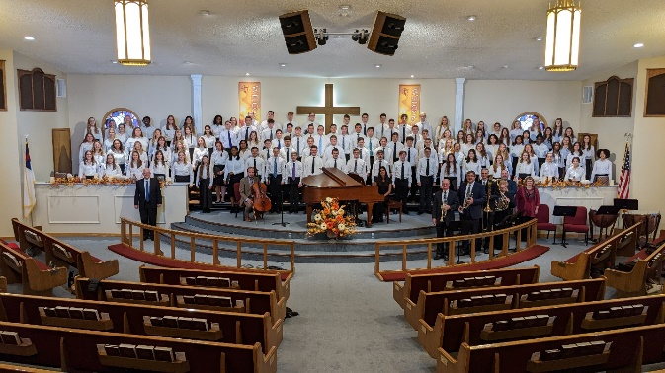

Different from our past pattern with the use of the Harrisburg Rotunda, for this year’s Choir event we utilized a venue that could accommodate the choir and their 500 parents and friends.
…
…
…
…
The students favor participation because they
4 get to develop relationships with Christian friends and buddies from across the state,
4 get to be in a large, serious choir doing music that sounds awesome,
4 get to learn from a different college professor each year, and
4 get a jump start on music at the college level.

The music teachers and tutors favor participation because they
4 get serious students through the screening and audition process even if only one or two students from their school want this experience and choral training,
4 get students exposed to a variety of composers and music periods and styles, and the repertoire for every year is unique,
4 get to learn from observing the different college professors, and
4 get to fellowship and share with other adult musicians.

The pastors and principals favor participation because they
4 get their students involved in an All-State activity with a proper spiritual and education focus,
4 get their students equipped with better skills and awareness for being a peer leader,
4 get to augment their in-school programs with something that attracts and retains a highly desirable type of families, and
4 get a good way to illustrate that there are other kids, families, and schools with which they share biblical priorities and academic excellence.
…
…
…
…
CARRIS KOCHER SENDS REMINDERS. As delegates have attended the KCEA Christian Education Conference, they have had opportunity to sit under this “walking historical encyclopedia” in workshops. History includes real people! They actually lived! Our heritage is important! Mrs. Kocher sends this message to you:

BILL OF RIGHTS DAY
Thursday, December 15, 2022

Is it marked on your calendar?
…
…
TEC:sc

