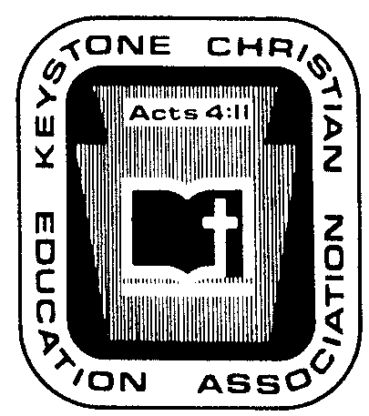
Keystone Christian Education Association

6101 Bell Road

Harrisburg, PA 17111
Phone (717) 564-1164

Fax (717) 564-1163

E-mail TClater@KCEA.com

Web www.KCEA.com

OCTOBER ’22 NEWS NOTES

P.R. IDEA OF THE MONTH. PASSING WORD ABOUT YOURSELF. It clearly appears that many Christian school websites seek to attract pre-teens and teens into enrollment – sports, fine arts, honors classes, post graduation plans. This reflects the personal focus of most pastors, principals, and other school leaders.
…
…
…
FEDERAL EMPLOYEE RETENTION TAX CREDIT. Unless your school leadership has been in a deep sleep for the past three years, you know that the federal government created a variety of programs to “aid” the economy when governments locked down our country due to COVID-19. While Roman Catholics and others have participated in “every” imaginable program and thus finance their activities, many of you have resisted or ignored these “opportunities,” usually based upon your philosophy of government and/or of Scripture.

Reminder: One Covid-related law could be considered to be different from the “handout” …
…
…
…
EDUCATIONAL CHOICE IS A GOOD GOAL, BUT IT IS GAINED INCREMENTALLY. Incremental steps toward a goal is not a new concept. That is what occurs in child rearing. That is how the “pro-life” movement has moved forward. That is how pastors teach/preach the Bible.

The term “educational choice” is a term closely related to public policy. “Educational choice” …
…
…
…
This past week, the nation’s report card on educational learning was released. This report card…
…
…
…

PA CHILD CARE REGULATION REWRITE AND LAST WEEK’S PUBLIC HEARING BY THE PA HOUSE COMMITTEE ON CHILDREN AND YOUTH, A SUMMARY.

Under the surface, what is this about?
…
…
…
What are the applicable statutes? …
…
…
…
Historically, how have religious Pre-schools been supervised under the law?
…
…
…

Historically, how have church or school ministries such as VBS, Stem Camp, After School Tutoring, and after school activities (athletics, drama events, etc.) been viewed?
…
…
…
What or who is the ultimate source of pressures to expand the areas of life where licensing would be required, (a) potentially to include VBS, Stem Camp, After School Tutoring, etc., and (b) potentially to include secular community activities and care of children by relatives?
…
…
…
So, why a public hearing before legislators and why now?
…
…
…
What happened in the public hearing?
…
…
…
How is this draft of the rewrite project different from or similar to the current regulations?
…
…
…
So, what should be done about this rewrite project, beyond praying for the soon return of our Lord?
…
…
…

TEC

