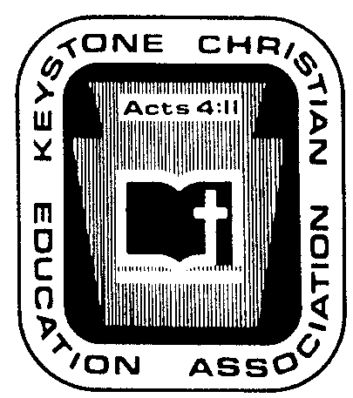
Keystone Christian Education Association

6101 Bell Road

Harrisburg, PA 17111
Phone (717) 564-1164

Fax (717) 564-1163

E-mail TClater@KCEA.com

Web www.KCEA.com

JANUARY ’24 NEWS NOTES

P.R. IDEA OF THE MONTH. CAUSE AND EFFECT. INEPT PUBLIC SCHOOL BOARD MEMBERS. The concept of a public school board is unique among the nations. We elect members. While it is seldom openly discussed, there is a major problem. While some elected members are credible, good leaders, worthy, capable, honorable, thinkers, knowledgeable (etc., etc.), the common knowledge in Harrisburg circles is that:
w Collectively the group needs help as some are an embarrassment, some self-serving, some big headed, some personal agenda driven, some “problem children,” some lazy, some know-it-alls, some lacking thinking skills (etc., etc., and some are likely labeled with unkind terms),
w There is a significant turnover among those elected or appointed,
w There is a high rate of declining to complete a first term or serve another term, and
w Few are trained in education-related matters or have an understanding of school law.
…
…
…

SUMMARY OF MAIL DISTRIBUTED FROM STATE GOVERNMENT. Consider two:

Attendance Report Computer Error. Each fall the state collects attendance numbers, and this is now accomplished through the PNPE system.
…
…
…

School Safety Grants. State government has reworked how schools can access “safety” money for mental health and student safety.
…
…
…

SUMMARY OF IMPORTANT E-MAIL TRANSMISSIONS IN JANUARY:

…
…
…

REQUESTING ASSISTANCE IN PLANNING 2024 CHRISTIAN EDUCATION CONFERENCE. We repeat what we articulated at the end of December.
…
…
…

2024 KCEA ALL-STATE CHOIR AUDIO RECORDING AVAILABLE. Our select-voice high school choir enjoyed a musical treat by singing and recording in the Capitol Rotunda on Friday, November 17. Contact the KCEA office to purchase a copy at $10.60 each to cover copyright and sales tax fees. One might desire a recording for personal enjoyment or to illustrate to high school students what a group of their peers can sound like. Terrific! Inspiring!

KCEA BUSINESS AT A GLANCE. Here is a summary of the discussions at the most recent KCEA Board meeting held on Monday, January 15, 2024, at the KCEA office at Harrisburg. The meeting covered about five and a half hours, including lunch.
…
…
…

TEC

